N**ew UNLV Education Certificate Programs:**

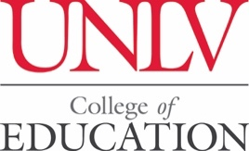

**Graduate Certificate in Global Teaching**

**Graduate Certificate in Global Teaching Research.**

**Certificate Programs begin Spring 2019.**

**UNLV Spring Applications Due**: Timeline: Non-degree-seeking applications

have a processing time of at least 3 business days.

To enroll in UNLV, please go to: [To Apply](https://www.unlv.edu/apply)

**ATTENTION: UNLV Announces Two New Education Certificates**

**INTENDED FOR**: Teachers who currently teach in an IB School or desire to teach in an IB School

**UNLV-International Baccalaureate (IB) Recognized Education Certificates**

**International Baccalaureate**® (IB) programs aim to do more than other curricula by developing inquiring, knowledgeable and caring educators who are motivated to succeed. The Department of Teaching & Learning in the UNLV College of Education offers IB certificate programs in Global Teaching (undergraduate- and graduate level) and Global Teaching Research (graduate-level).

***A continuum of international education***

IB Education programs at UNLV encourage both personal and academic achievement, challenging students to excel in their studies and in their personal development.

***Quality practice***

Our IB programs incorporate quality practice from national and international research and the IB global community. They encourage students to be internationally-minded, within a complex and hyper-connected world.

***Learning how to learn***

Courses are rich with opportunities for students to try different approaches to learning and to take responsibility for their own educational progress.

Our programs help students:

* ask challenging questions;
* think critically;
* develop research skills proven to help them in higher education; and
* be active in their communities and to take their learning beyond academic study.

**The two New IB recognized UNLV Certificates are intended to prepare educators to meet the IB requirements for the** ***IB Certificate in Teaching and Learning***” and the ***IB Advanced Certificate in Teaching and Learning Research***.

* 1. **UNLV Graduate Certificate in Global Teaching**: The UNLV-IB recognized [**Graduate Certificate in Global Teaching**](https://www.unlv.edu/certificate/grad-cert-global-teaching) prepare students to apply for the International Baccalaureate (IB) ***IB Certificate in Teaching and Learning***.  **The Graduate Certificate for Global Teaching prepares students with the knowledge, skills and dispositions to teach in International Baccalaureate World schools in Nevada and around the world.**

**With advisor approval,** students are able to enroll in this Certificate Program as a component of a graduate degree program or as a standalone “Certificate Only” program. Students can complete the program within one year. Program courses are offered Spring, Fall and Summer Semesters. International students applying for the “Certificate Only” program will not be eligible for a US Visa or I:20. (need exact forms).

* + - **Program of Study: (20 semester credit hours) (Spring 2019 courses will be offered online only).** 
      * **CIG 605**: Elementary and Secondary Methods and Assessment for Global Teaching (Spring 2019)
      * **CIG 681**: Curriculum Implementation and Innovation
      * **CIG 608**: Student Internship (Spring 2019)
      * **CIG 609**: Student Residency (Spring 2019)
      * **CIG 688**: Teaching and Learning Seminar (Spring 2019)
* **Requirements**:
  + - * Apply and enroll in Certificate Program at UNLV [To Apply](https://www.unlv.edu/apply)
      * Must meet both UNLV and IB requirements
      * All Field-Experiences in IB schools.
* **Methods of Delivery**:
  + - * Online, Blended, and Face to Face courses will be offered.
      * **Any school that has ten or more teachers enrolled may have the opportunity for the course to be offered at your school location.**
  1. **Graduate Certificate in Global Teaching Research:**  The UNLV-IB recognized [**Graduate Certificate in Global Teaching Research**](https://www.unlv.edu/certificate/grad-cert-global-teaching-research) prepares students to apply for the International Baccalaureate (IB) ***IB Advanced Certificate in Teaching and Learning Research***. The UNLV ***Graduate Certificate in Global Teaching Research*** has a strong focus on systematic and rigorous educational inquiry. The certificate program requires participants to ground their inquiry in issues relating to international education. Participants will have the opportunity to identify their own areas of inquiry within the context of their current practice and will critically engage with the relevant bodies of literature and contemporary research. Participants will design and conduct one or more research studies.

**With advisor approval,** students are able to enroll in this Certificate Program as a component of a graduate degree program or as a standalone “Certificate Only” program. Students can complete the program within one year. Program courses are offered Spring, Fall and Summer Semesters. International students applying for the “Certificate Only” program will not be eligible for a US Visa or I:20. (need exact forms).

* + - **Program of Study: (12 semester hrs) (Spring 2019 courses will be offered online only).**
      * **CIG 686:** Teachers and Professionals as Change Agent (Spring 2019)
      * **EPY 702:** Research Methods
      * **CIG 690:** Action Research
      * **CIG 688:** Teaching and Learning Seminar
    - **Requirements**:
      * Apply and enroll in UNLV: [To Apply](https://www.unlv.edu/apply)
      * Must meet both UNLV and IB requirements
* **Methods of Delivery**:
  + - * Online, Blended, and Face to Face courses will be offered.
      * Any school that has ten or more teachers enrolled may have the opportunity for courses to be offered at your school location.

To enroll in UNLV, please go to: [To Apply](https://www.unlv.edu/apply)

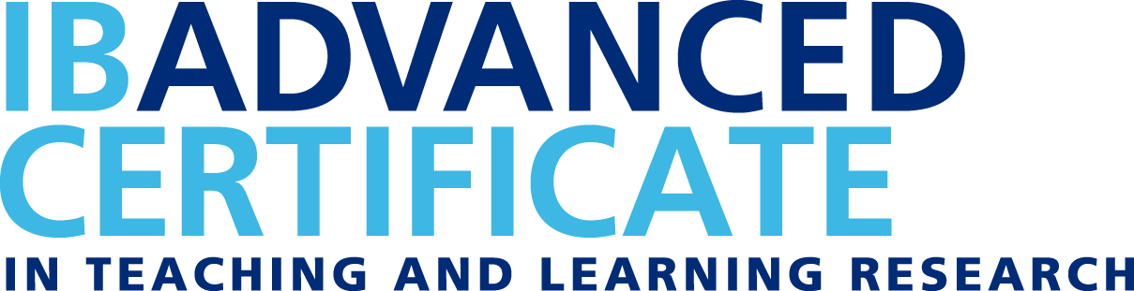



_____________________________________________

For Additional Information or Questions please contact:

**Dr. Travis Olson: Graduate Coordinator**: Email: [travis.olson@unlv.edu](mailto:travis.olson@unlv.edu) (Tel) 702-895-0471

**Dr. Greg Levitt: Secondary and IB Coordinator**: Email: [glevitt@mac.com](mailto:glevitt@mac.com) (Tel) 702-682-6011 (Cell)

**Dr. Linda Quinn**, **Elementary and IB Coordinator**: Email: [linda.quinn@unlv.edu](mailto:linda.quinn@unlv.edu) (Tel) 702-895-0879

**Please share this Announcement with your IB colleagues and anyone interested in IB Certificate programs.**

UNLV Department of Teaching & Learning  
Carlson Education Building  
Department Office CEB 354  
4505 S. Maryland Parkway, Box #453005  
Las Vegas, NV 89154-3005  
702-895-1540